Venue Info
MERCURE GRAZ CITY
Lendplatz Immobilienverwertungsges.m.b.h.
Lendplatz 36-38
8020 Graz – Austria
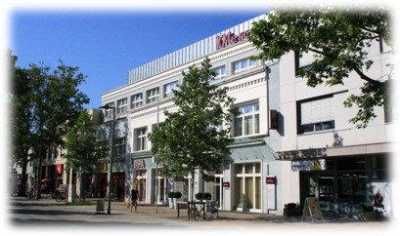
Venue Location: Mercure Graz City

Equipment:
Room size: 75m²
Room height: 3m
- Daylight
- air-conditioned
- Projector
- PC audio
- Free Wi-Fi
- 2 pinboards
- 2 flipcharts
- Analog and digital telephone connection
- Conference phone
U-shape: 25 participants

AVL location: Hans List Platz
Note: Keep in mind that the meeting will be in a hotel nearby.

Nearest/commonly used hotels:
- Hotel Mercure Graz City, Lendplatz 36 - 38, 8020 Graz (this is where the majority of the meeting will take place) https://all.accor.com/hotel/5742/index.en.shtml
- Lendhotel, Grüne G. 2, 8020 Graz https://lendhotel.at/en/
- Hotel Daniel Graz, Europapl. 1, 8020 Graz https://hoteldaniel.com/en/graz/
- ibis budget Graz City, Neubaugasse 11, 8020 Graz https://all.accor.com/hotel/5107/index.en.shtml
- IGNORE – this one seems to be permanently closed
- Hotel Mariahilf, Mariahilfer Str. 9, 8020 Graz https://hotelmariahilf.at/?lang=en

Note: The hotels are not in a particular order of preference (generally, the price reflects the quality). These are the closest ones to AVL, but there are plenty of other ones around. The city is relatively small, so most of the things are easily reachable on foot.

Getting here:
- Graz airport:
  - Taxi (€20-€30) 20-30 mins from the city
  - S-Bahn (~€3.00) a bit longer. Subject to the timetable (going to Graz Hbf and then walking 15 mins)
  - Bus – similar to S-Bahn (S5) – the timetable is here
- Vienna airport:
  - (~€50.00) Train to Graz Hbf (normally every hour – duration 3 hrs either direct or with a 5-10 mins change at Vienna Hbf) and then 15 mins walk – timetable

- Graz airport is not the most frequented in the best of the times (unless you are traveling from Germany). Most of the connections are via Frankfurt/Munich/ Vienna.
- Suggestion: fly to Vienna and then grab a train or Flixbus
  - Train: if you are sure of the times, you can pre-book tickets here – you are getting a ticket from VIE (Vienna International Airport) to Graz Hbf. You either need to change trains in Vienna Hbf or the train goes directly to Graz. Some people might stop over in Vienna anyhow, in which case, you are getting one ticket to Vienna and then another one from Vienna to Graz.
  - Flixbus – tickets: you are booking a ticket from Vienna Airport to Graz Girardigasse

Also, for the F1 fanatics:
As there were some hints of interest (while discussing in Cagliari), the F1 Austria race is on the weekend after our meeting. The location is Red Bull Ring Str. 1, 8724 Spielberg, Austria, which is about an hour's drive (in normal conditions – no idea what it is like on the race day) from Graz. Some tickets seem to be still available.

